1.SELECT * from obat_2 ORDER BY nama_obat desc

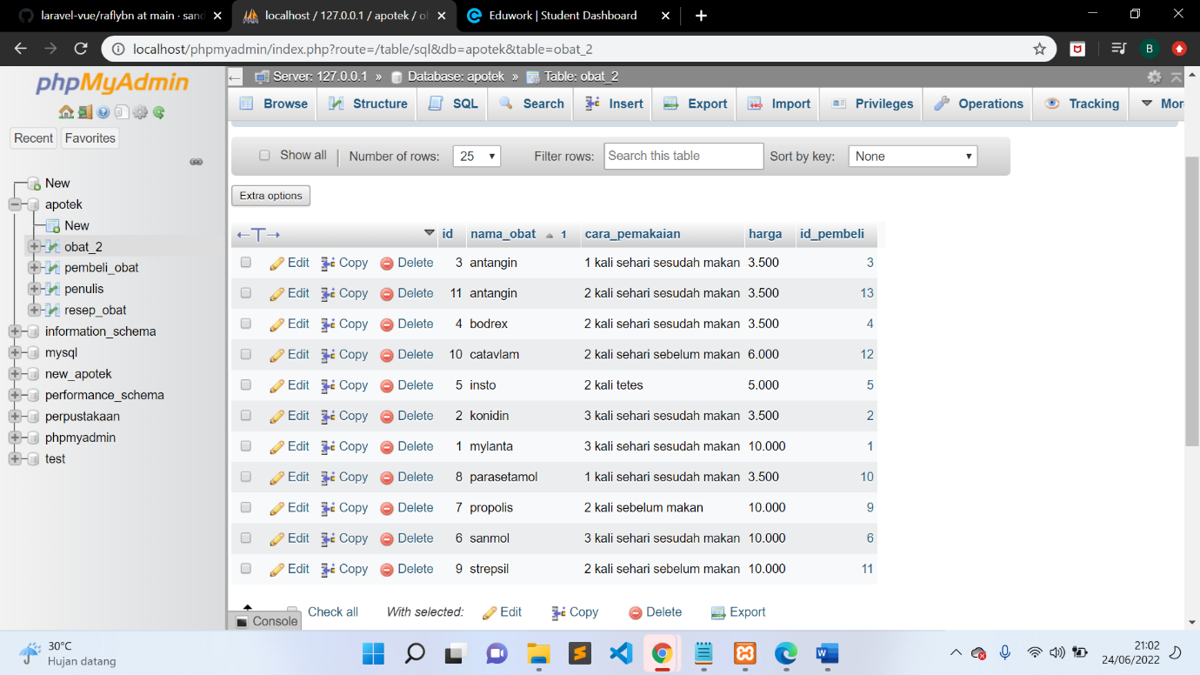

2.SELECT * FROM obat_2 ORDER BY nama_obat ASC

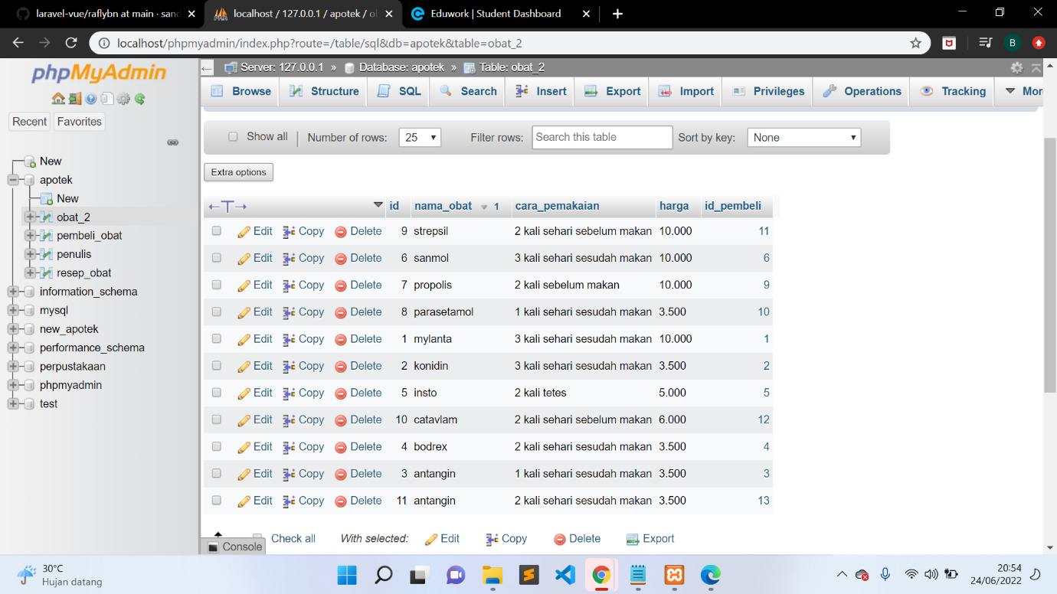

3.SELECT * FROM obat_2 WHERE cara_pemakaian LIKE ‘%sesudah makan%’ 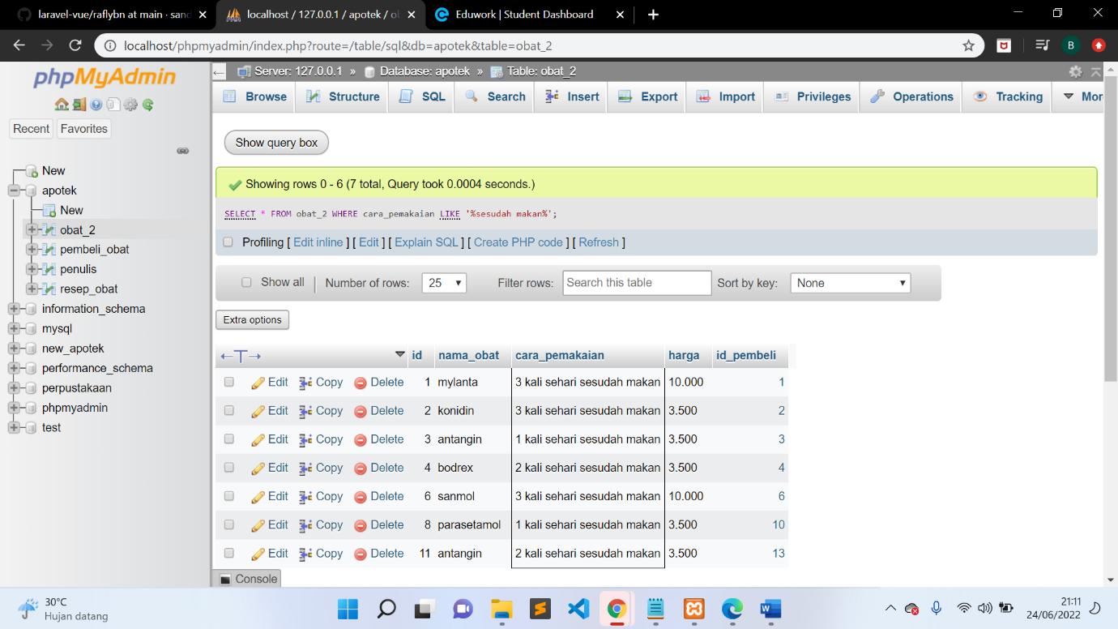

4.SELECT nama_obat, SUM(harga) as total FROM obat_2 GROUP BY nama_obat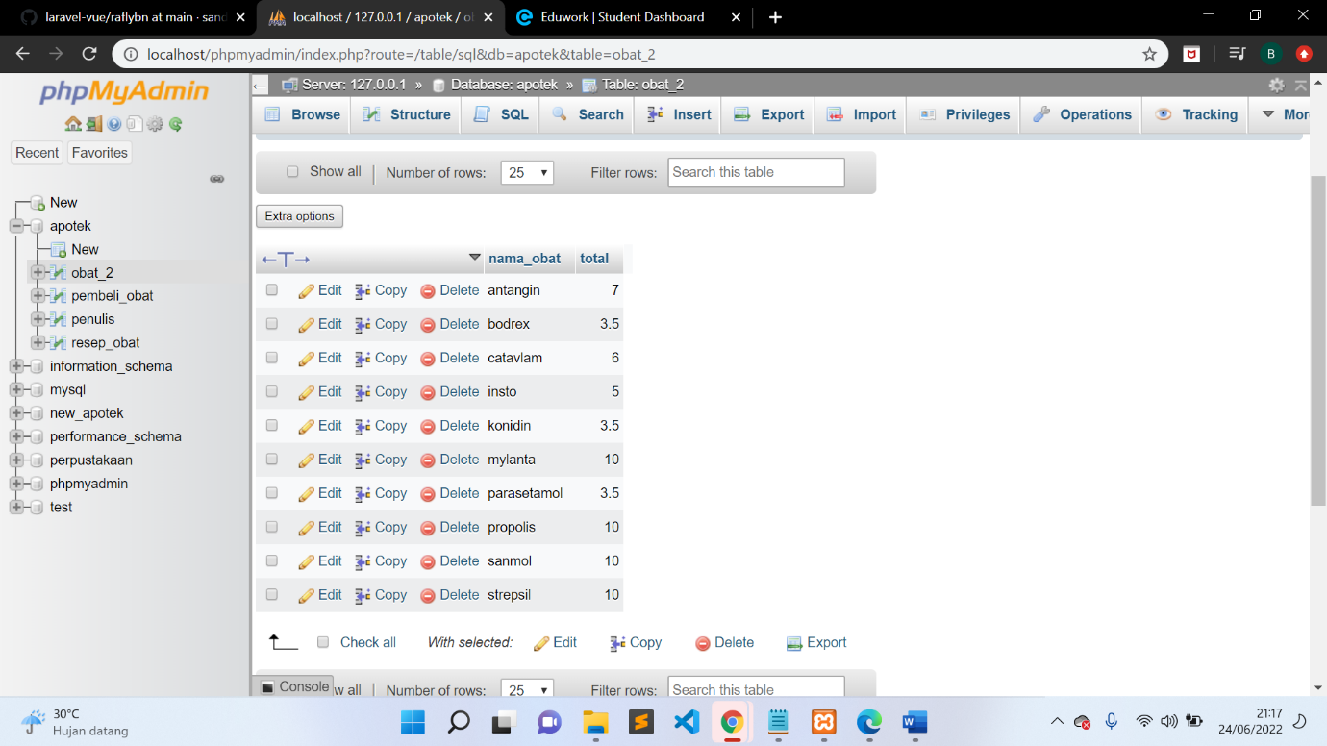

5.SELECT id_pembeli, SUM(harga) as total FROM obat_2 GROUP BY id_pembeli 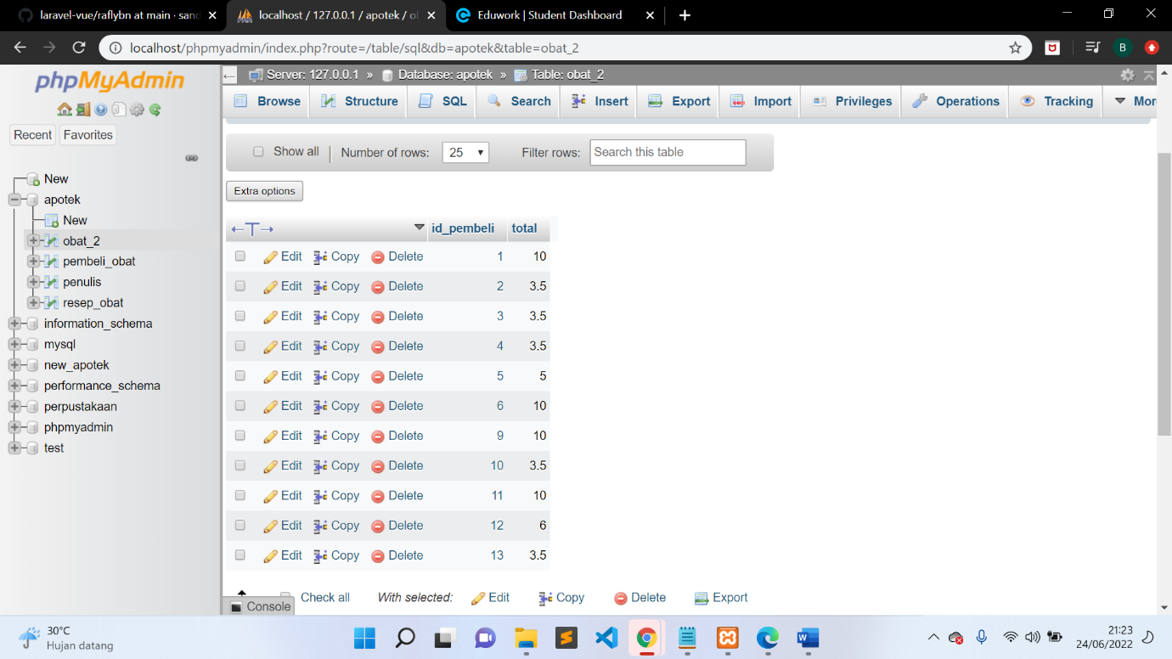

6. SELECT id_pembeli, SUM(harga) as total FROM obat_2

WHERE id_pembeli >= 1

GROUP BY id_pembeli

ORDER BY id_pembeli DESC 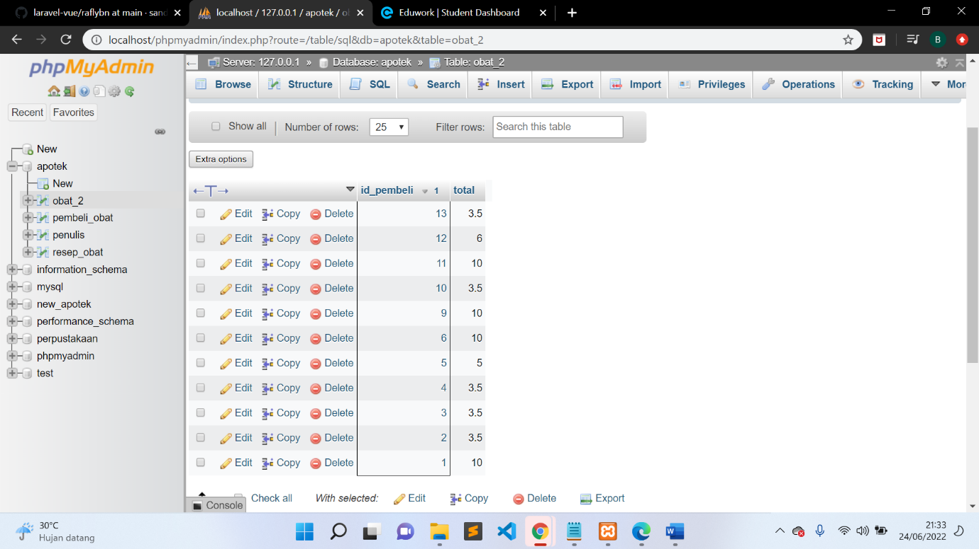

7. SELECT id_pembeli, SUM(harga) as total

FROM obat_2

WHERE id_pembeli >= 1

GROUP BY id_pembeli

ORDER BY id_pembeli ASC 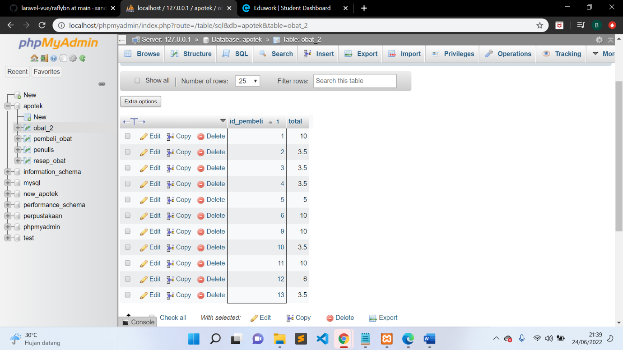

8. SELECT id_pembeli, SUM(harga) as total FROM obat_2 GROUP BY id_pembeli

ORDER BY id_pembeli DESC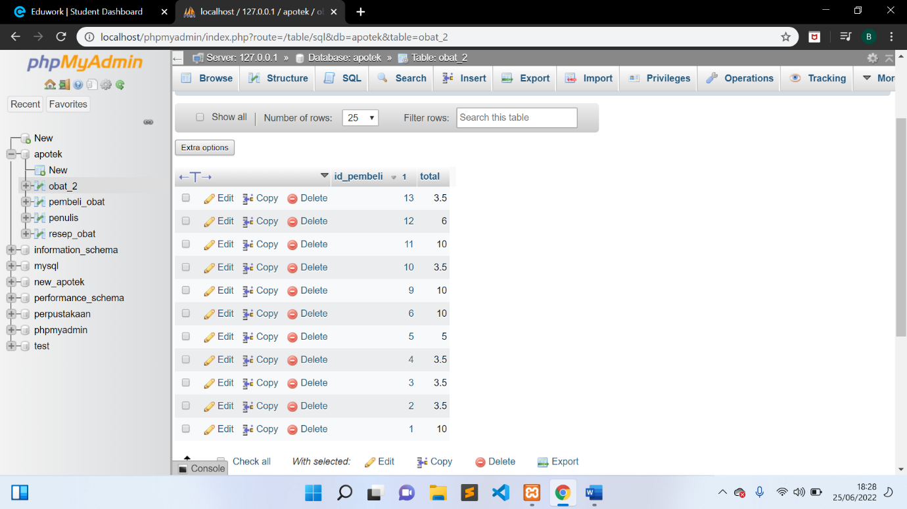

9. SELECT id_pembeli, SUM(harga) as total

FROM obat_2

GROUP BY id_pembeli

ORDER BY id_pembeli ASC